There are different approaches for predicting the cutomer lifetime value (CLV):

- Take as input for a model customer features like what is his sector, how big is that customer (is it big or small company, or individual person, for how long he is our client, what is his sector), number of monthly sales orders from last few months. All of this is an input for a single model.

- Another approach is similar to the previous one. We take as input the same features but they are input for two seperate models.

Number of sales orders is input for one model, for example LSTM, and customer features are input for another model, for example fully connected neural network. If x1 is our time series data (number of sales orders in each day or month) and x2 are client features (for how long is he buying our products, what is his sector), then model architecture can look like this:

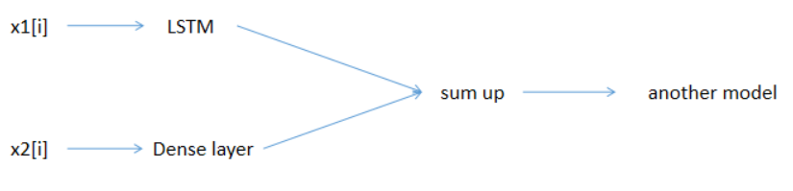

I think that instead of using multiple different models we can use the Autoformer model.

- We calculate different features from dataset about sales orders. We need to choose what is our threshold date:
  - Recency - the difference in days between the last purchase and the threshold date
  - Revenue - total revenue until the threshold day
  - No_sales - total amount of sales orders until the threshold day
  - MaxRevenue - maximum revenue in a single day/week/month until the threshold day

For different threshold dates we will receide different features for our customers.

Based on those features we can cluster our cutomers. We create a seperate cluster for each feature, for example:
- recency clusters where higher cluster number indicates a smaller recency
- Revenue clusters where higher cluster number indicates a higher revenue

Then we can calculate the overall score for example by summing cluster numbers for different features.

What we can predict:
- the overall score - classification
- To which revenue (for the next 3 months) cluster customer belongs - classification
- Revenue for next 3 months - regression

Useful website: https://www.kaggle.com/code/shailaja4247/customer-lifetime-value-prediction

